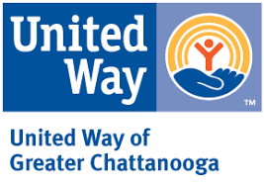

Date

Name
Address
City, State ZIP

Dear Name,

Despite all the progress we’ve made, Chattanooga still needs a movement.
Our region has the 12th highest rate of income inequality in America, and we’re the 9th worst city for upward economic mobility, since 70% of children born into poverty will stay stuck there for life. Even with all the ways we’ve grown and improved over the last generation, the gap between those who succeed and struggle is still getting wider.

This movement needs leaders like you.
Every great movement has leaders, those early adopters who run ahead and challenge others to catch up. You’ve got what it takes to be one of those leaders. As part of the United Way of Greater Chattanooga Leadership Club, you’d join a growing corps of community members who are fighting for children and families. We believe that a connected community changes everything, and have worked to position United Way as no longer a community chest, but the most pivotal community change agent in our region.

Join the movement by joining the Leadership Club.
Leadership Club members believe that Chattanooga’s best days are still ahead. Your support helps United Way connect people with services and organizations with resources in order to improve our community. Most importantly, the Leadership Club is for neighbors like you who care deeply about Chattanooga and answer the call to help every one of us thrive.

Help create the connected community we know will change everything!
I know how much our community’s health and success means to you. That’s why I personally invite you to join our Leadership Club with a minimum tax-deductible gift of $1,000 this year. What I can promise you in return is that you will know the impact of your giving. You will hear from individuals on the front-lines responsible for connecting us, block by block. You will see and feel a bolder, brighter Chattanooga thanks to your support.

And if you’re like me, you will feel much more grateful to be part of our hometown.

United,

Your Name
Title

