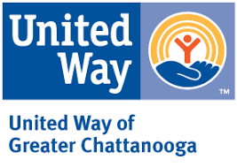

DATE

NAME
ORGANIZATION
ADDRESS
CITY, STATE, ZIP

Dear NAME,

Greetings from the United Way of Greater Chattanooga! I am writing with the hope that you and I may be able to arrange a brief face-to-face meeting in the coming weeks.

As a member of our Board of Directors, it is my pleasure to express gratitude for the many ways your past support has strengthened our outcomes. Throughout your involvement with United Way, I hope that you have seen, heard and felt the impact that your generosity has made possible. We believe that a Connected Community Changes Everything, and cherish our role as the organization connecting people to services and organizations to resources in order to solve our community’s most pressing issues and critical problems.

My role is to simply thank you, and to ensure you know that you have been invaluable. The impact of your contributions can be demonstrated, and is impressive.

I also hope I can share with you what’s new at United Way, including our efforts to support and empower on-the-ground community leaders and data experts; our change to the traditional United Way allocation model, and our partnerships with government, corporate and nonprofit partners to accelerate solutions that improve the community’s opportunity for education, health and well-being, and financial stability. When those things are in place, upward economic mobility and social equity will follow!

I am planning to phone you within a week to arrange a time to meet with you. I hope you will accept this request. Meanwhile, please contact me any time on my cell phone at _____ or my e-mail address, _____. I would be delighted to hear from you with any questions or feedback. I’m looking forward to setting an in-person meeting at a time and place of your choosing.

Thank you again for all you have helped us do to create the connected community we desire.

United,

Name
Board of Directors
United Way of Greater Chattanooga

